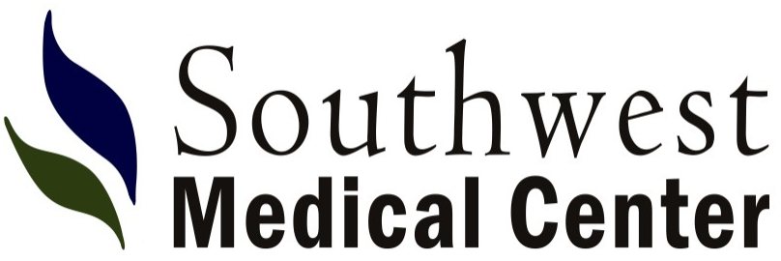
315 W. 15th Street
Liberal, KS
(620) 624-1651
www.swmedcenter.com

DIRECTORY OF PROVIDERS

Anesthesiology
Brandon Mack, M.D.
Bruce Cook, CRNA
Elvis Kasi, CRNA
Bonnie Porter, CRNA
(620) 624-1651

Dermatology
Mark Kaminski, M.D.
15 E. 11th Street
(620) 624-9100

Emergency Room
(620) 624-1651

Family Medicine

R. Kelly McMurry, D.O.
Baolong Do, APRN-C
123 Medical Drive, Guymon, Okla.
(580) 338-3361

Linsey Carter, DNP, NP-C
Tracy Fowler, APRN-C
Britt Short, APRN-C
Laura Kane, APRN-C
555 W. 15th Street
(620) 624-0702

General Surgery
Anthony Galitsky, M.D.
Jose Maeda, M.D.
305 W. 15th Street, Suite 204
(620) 624-4946

Hospitalists
Rama Chanda, M.D.
Andrey Ilyasov, M.D.
Akshath Kamath, M.D.
Rachel Andreas, P.A.-C
Unnati Basnyat, P.A.-C
Marlon Bazan, P.A.-C
Elyse Bigler, P.A.-C
Bishal Bista, P.A.-C
Lauren Boyce, P.A.-C
Derick Samafuhbi, P.A.-C
Christopher Wentling, P.A.-C.
Bereket Woldemariam, P.A.-C (620) 624-1651

Internal Medicine
V. Randy Gill, M.D.
111 E. Tucker Road, Suite 7
(620) 624-1100

Juvenal Jabel, M.D.
102 E. 11th Street
(620) 624-2565

Sharon Mitchell, M.D.
13 Village Plaza
(620) 624-0604

Obstetrics/Gynecology

Lamberto Flores, M.D.
Victoria Underwood, APRN-C
305 W. 15th Street, Suite 104
(620) 624-9637

Dennis Knudsen, M.D.
Melia Stoll, APRN
P.O. Box 2529
222 W. 15th Street
(620) 624-3811

Megan Furnish, APRN-CNM
421 Medical Drive, Guymon, Okla.
(580) 338-3135

Orthopedic Surgery &
Sports Medicine
Pingal Desai, M.D.
Firas Kawtharani, M.D.
305 W. 15th Street, Suite 102
(620) 624-0732

Pediatrics

Nargis Husainy, M.D.
117 W. 4th Street
(620) 624-5066

Mariana Lucero, M.D.
2132 N. Kansas, Suite B
(620) 624-740

Plastic, Reconstructive, & Cosmetic Surgery
Mona Rane, M.D.
109 E. 11th Street
(620) 624-8500

Radiology
Robert Williams, M.D.
(620) 624-1651

OUTREACH PHYSICIANS

Cypress Heart Cardiology
Ryan Beard, M.D.
Daniel R. Alvarez, D.O.
Ahmad Qaddour, M.D.
305 W. 15th, Suite 103
(620) 629-6392 or
(316) 858-9000

Kidz Cardiology (Pediatric Cardiology)
Tuan Nguyen, M.D., F.A.A.P.
305 W. 15th Street, Suite 102
(316) 670-3800

Cancer Center of Kansas
Shaker Dakhil, M.D.
Dennis Moore Jr., M.D.
Quoc V. Truong, M.D.
315 W. 15th Street
(620) 629-6727 or
(316) 262-4467

Central Care Cancer Center
Oncologist
Jose Velasco, M.D.
305 W. 15th Street. Suite 203
(620) 624-4700

Revised 07/06/21

